
Name___________
Year 8 Science
Task 10: Physics 1 Test (Total: 50 marks)

SECTION 1: MULTIPLE CHOICE (1 mark each)
Circle your answer on the multiple choice answer sheet.

- Which is the best definition of energy?

  - A measure of the ability to do work.
  - A measure of the motion of an object.
  - A measure of the temperature of something.
  - A measure of the amount of matter in an object.

- An object that is sitting still on the top of a hill has

  - a lot of potential energy and not much kinetic energy.
  - a lot of kinetic energy and not much potential energy.
  - a lot of kinetic and potential energy.
  - not much kinetic or potential energy.

- Energy is measured in

  - metres (m)
  - Newtons (N)
  - Joules (J)
  - Watts (W)

- Which of these is not a type of energy?

  - elastic
  - light
  - heat
  - pushing

- Which type of energy is contained in food?

  - mechanical
  - chemical
  - solar
  - nuclear

- Which of these is not a sustainable or renewable energy source?

  - solar panels
  - wind turbines
  - diesel generator
  - wave generator

- The original source of all energy on Earth is

  - the sun.
  - plants.
  - fossil fuels.
  - food.

- A hair dryer works by which of the following energy transfers and transformations?

  - Electrical energy is converted to heat energy and kinetic energy.
  - Heat energy is converted to electrical energy and kinetic energy.
  - Kinetic energy is converted to heat energy and electrical energy.
  - Heat energy and kinetic energy are converted to electrical energy.

- In a light bulb, the useful energy output is

  - sound.
  - heat.
  - light.
  - electric.

- Which of the following best describes the energy transformation within a microphone?

  - Kinetic energy is converted to sound energy.
  - Kinetic energy is converted to potential energy.
  - Electrical energy is converted to kinetic energy.
  - Kinetic energy is converted to electrical energy.

- Plants transform light energy from the sun into stored chemical energy by the process of
- Respiration
- Solar Cells
- Growth
- Photosynthesis

- As compared to air, sound travels fastest in
- Liquids
- gases
- vacuum
- solid

13. Which of these is not a method of heat transfer?

  - convection
  - conduction
  - radiation
  - insulation

14. Which of the following is the most effective heat insulator?

- metal
- wood
- air
- a vacuum

15. A material which easily allows heat to move through it is called

- an insulator.
- a conductor.
- a resistor.
- a circuit.

16. The type of energy that is found in moving objects is called
a) potential.
b) kinetic.
c) gravimetric.
d) kinaesthetic.

17. When heat radiation hits a transparent surface such as glass, it may travel straight through, as shown in the diagram below.
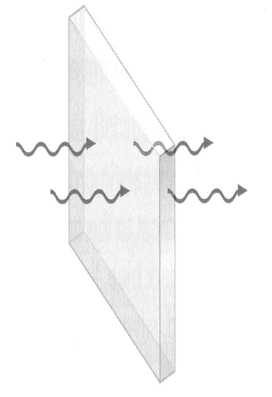
This is called
- transmission
- reflection
- absorption
- refraction

18. Which type of surface tends to be a good heat absorber?

- dull and dark
- shiny and light
- sparkly and colourful
- transparent

19. Most of the heat energy lost from a house in winter is lost through the

- floor.
- roof.
- windows.
- doors.

20. At a party drinks are often put into ice to keep them cool. The drinks are kept cool because of

- insulation.
- radiation.
- evaporation.
- Conduction

SECTION 2: WRITTEN
Write your answers in the spaces on the answer sheet provided.

- Classify each of these energy types as energy in kinetic (action) or potential. (5)

- Chemical _____________________

- Elastic _____________________

- Gravitational _____________________

- Heat _____________________

- Sound _____________________

- Using the types of energy from question 1 complete the correct types of energy below (9)

Appliance | Input Energy | Source | Output Energy | Receiver
electric toaster | (a) | power point | (b) | (c)
solar hot water system | (d) | (e) | heat | (f)
petrol engine | chemical | (g) | (h) | (i)

- State one problem that is associated with using fossil fuels. (2)

- A hot water system is 65% efficient. If it is supplied with 1000 Joules of energy, how much heat energy will it produce? Show all working out. (2)

- Draw an energy flow diagram to represent the coal fired power station shown in the diagram below (4)

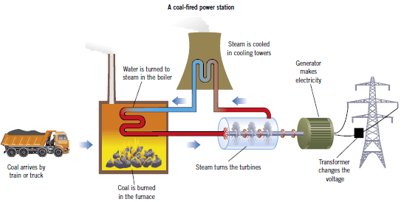

- The diagram below shows conduction, convection and radiation.
Use these diagrams to explain how heat travels by each method.(3)
Answer on the next page

Method of Energy Transfer | Explanation of how heat travels this way.
Conduction

Convection

Radiation

These methods of heat transfer travel through solids, liquids and gases.
Label the following as a good or poor conductor of heat. (6 marks)

State | Solid | Liquid | Gas
Conduction |  | Good
Convection |  | Good
Radiation |  | Poor

END OF TEST (OUT OF 50 MARKS)

